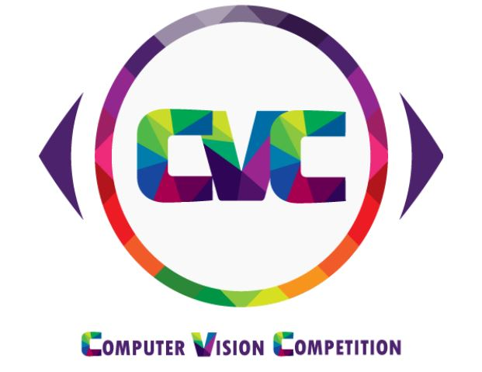

**Wall Painter**

**Night Kings Team**

# Description:

All of us faces the problem of being not able to choose our wall painting color, is the color we chooses suitable for the rest of the apartment and furniture in the room?

And sometimes we choose a color thinking it is good and after painting we don’t like it because it is different of what we thought.

So what about an application helps us in this problem and helps us visualize our new painting better before we actually start painting

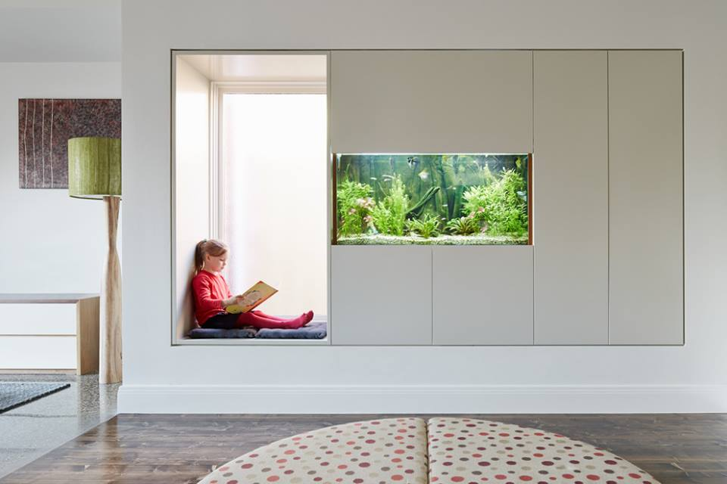 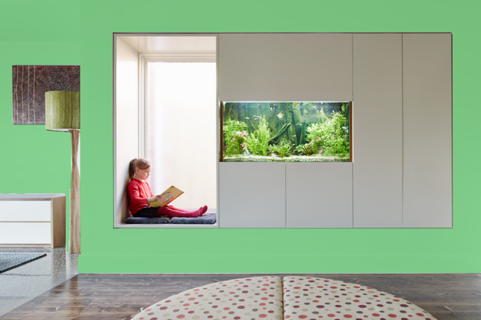

Before After

So to use our application simply do the following:

1- Take a picture of the room with its current state and the furniture around it

2- Detect the wall only without furniture

3- User enter the color code from the painter shop

4- Give the user a picture with the new color

# Project Plan:

Our project implementation is going to pass by several implementation steps:

* Detect the wall
* Design a simple User Interface Application that captures an image of wall.
* Implement an algorithm that detects the wall where without furniture.
* Implement an algorithm that refines the image, rotates, transforms it, etc.
* Implement an algorithm that changes the color of the wall only from the image.
* Merge the User Interface Application with the implemented algorithms to get the targeted output

# Implementation Considerations:

# - Frontend of the project will be implemented using **Ionic**, a cross-user-interface-platform, which develops applications for android, iOS, Windows Mobile, Desktop, Web and etc...

# - Backend of the project will be implemented using **Python programming** language because of its high capabilities and its powerful libraries concerning image processing problems such as the famous openCV library which we are going to use beside our implemented algorithm to reach our targeted output with the least error percentage that could be reached.

# Team members:

1. Mahmoud Ahmed Mohamed Khyralah
2. Mamoud Samir Mohamed Eidarous
3. Mostafa Tawfiq
4. Mostafa Saber

Students in the fourth year of the electrical engineering department – Computers and Systems Engineering – Ain Shams University.

**Thank you**